Git Commands

-------------------

1. To know your git user_name :

git config user.name

Example:

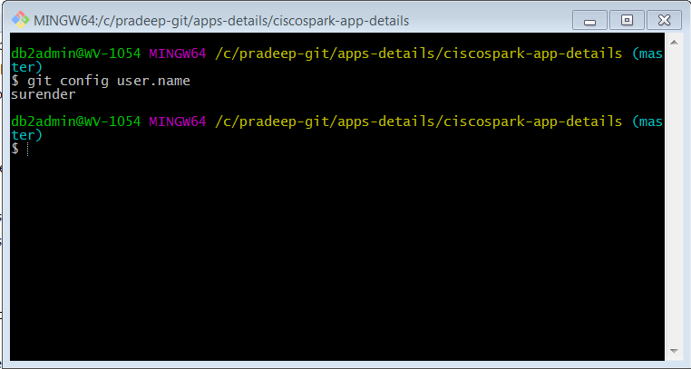

2. To change/assign your Git username :

git config --global user.name "Alvin J. Alexander"

3. To know your git email :

git config user.email

Example:

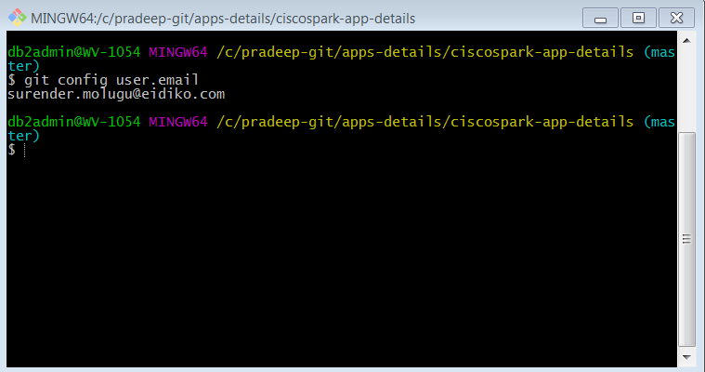

4. To change/assign your Git email :

git config --global user.email <your_email_address_here>

5. To create a local copy of a remote repository:

git clone <repository_url_provided_by_Github>.

to get repository_url, Open the repository you want to clone and copy the url as shown below.

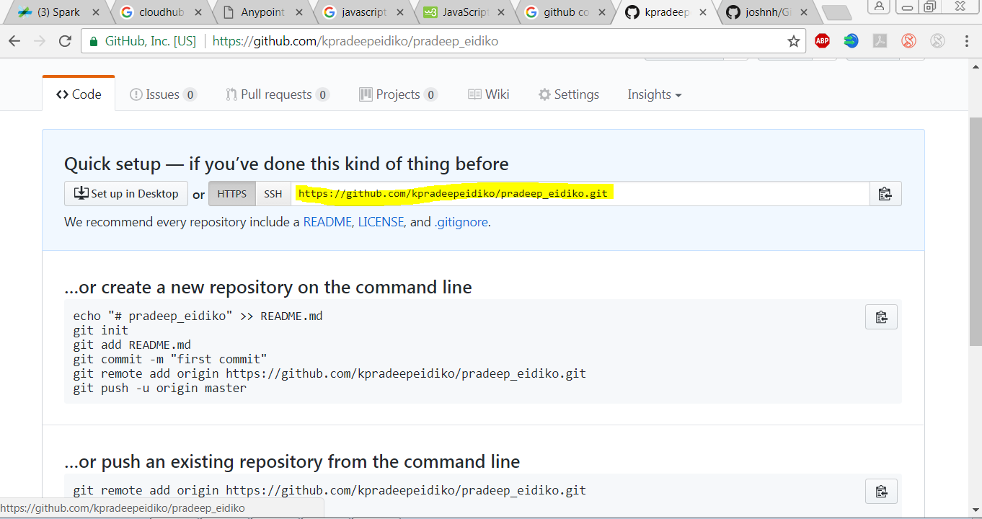

6. To "pull "copy of a remote repository:

git pull origin master

Example:

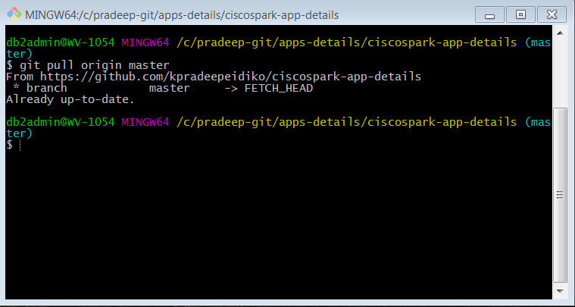

Note: Here in above command "master" is your type of branch of your repository. This will available when you open your repository(by logging into you github account from web-browser) as following.

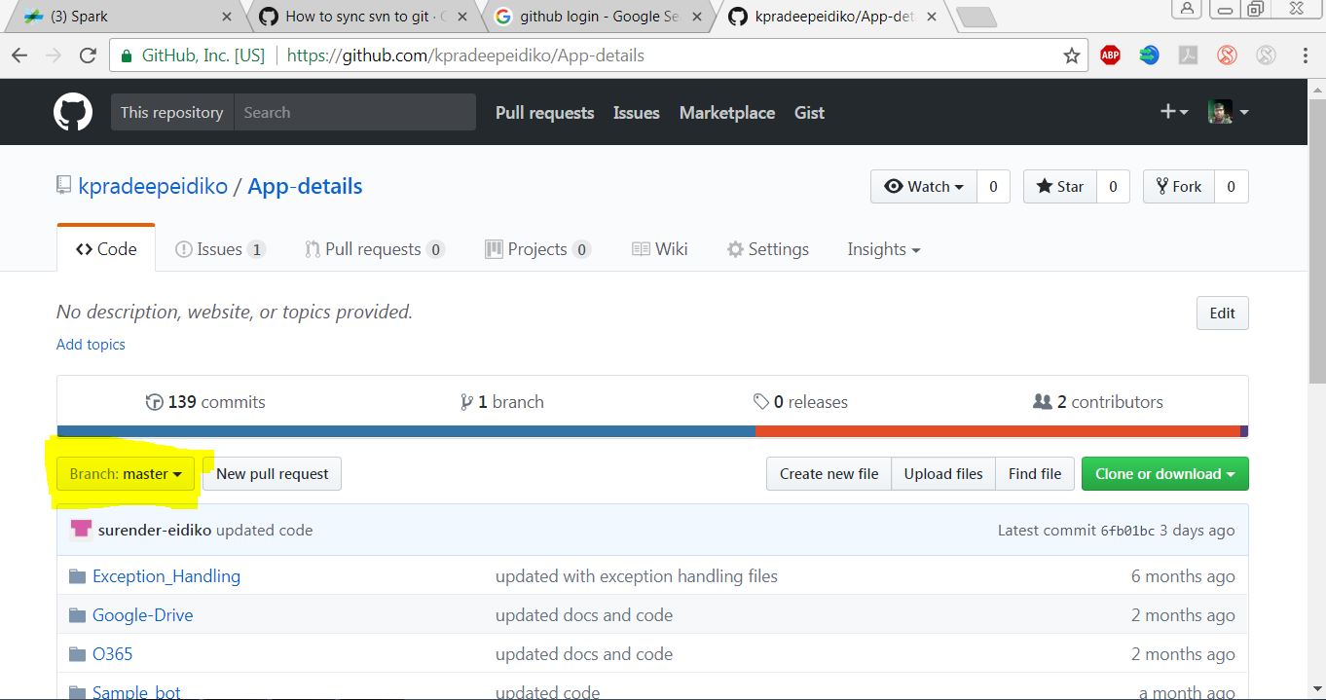

-->If your repository is public, than it won't ask for authenticate(username/password).

--> If your repository is private, than it prompt for authenticate(username/password).

7. To "push" copy of a remote repository: follow following procedure

* Open "Git Gui Here" by entering in to your local repository(right click the mouse). As following.

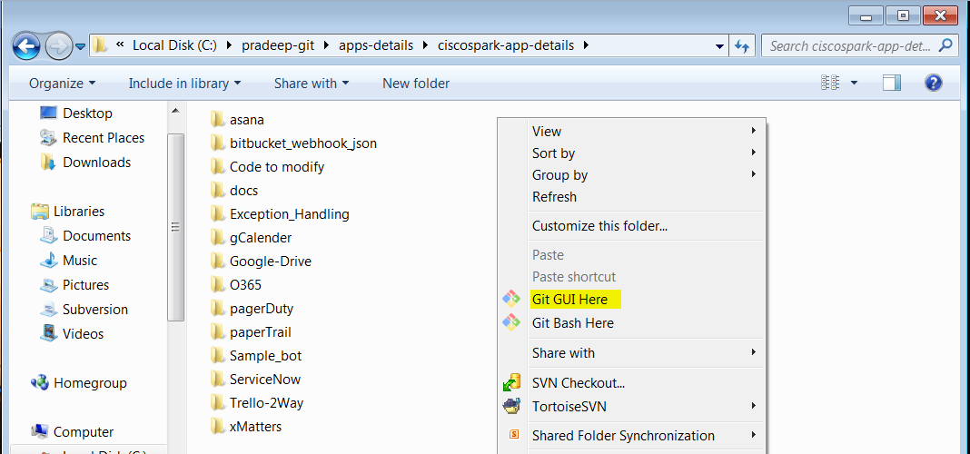

* After clicking "Git Gui Here" then a screen will prompt, showing all changed files, as following.

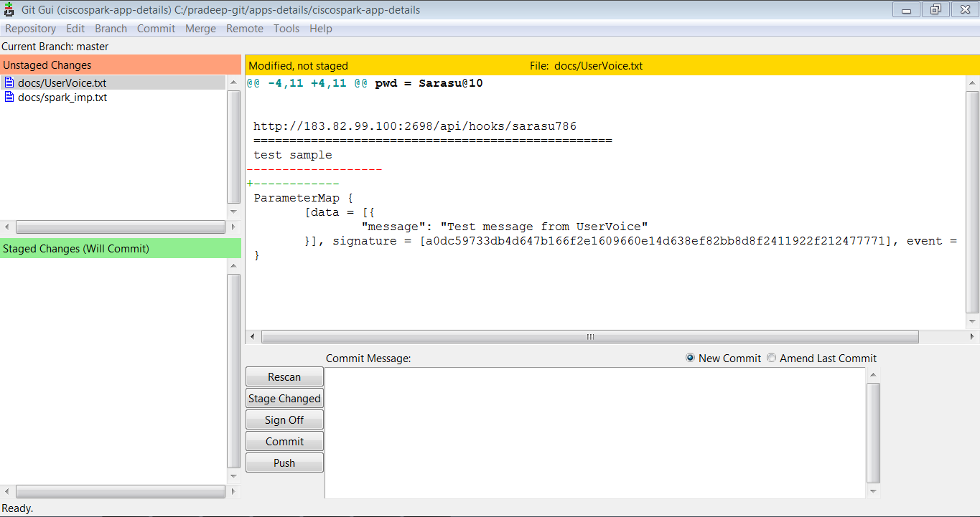

* Now Select all changed files and click "Commit" from the tab, a pop-up will appear than select "stage to commit" option as following.

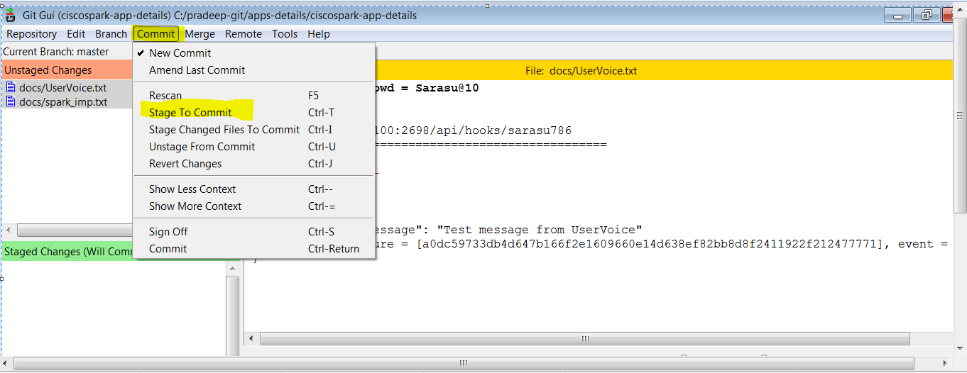

* Now write reason for commit in the "commit message textbox" and click "commit" button which appears on left side of commit message textbox as following.

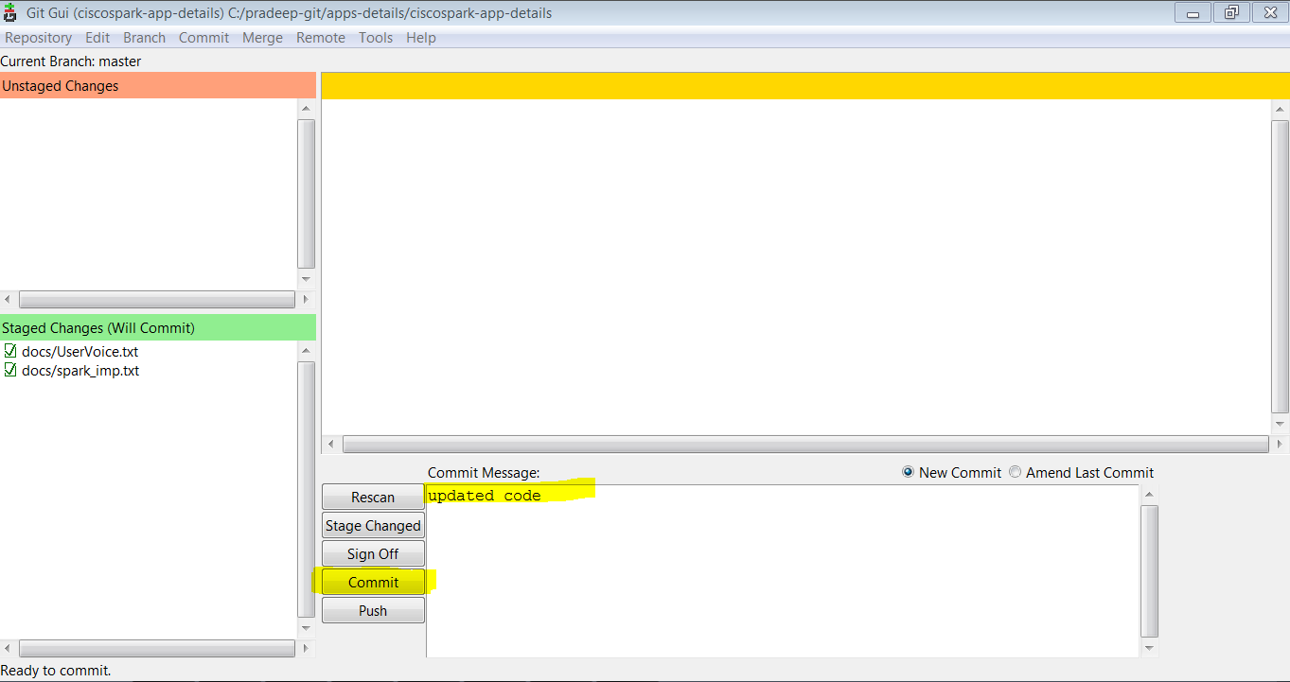

* Now open "Git Bash Here" from local repository folder(by right clicking mouse) as following.

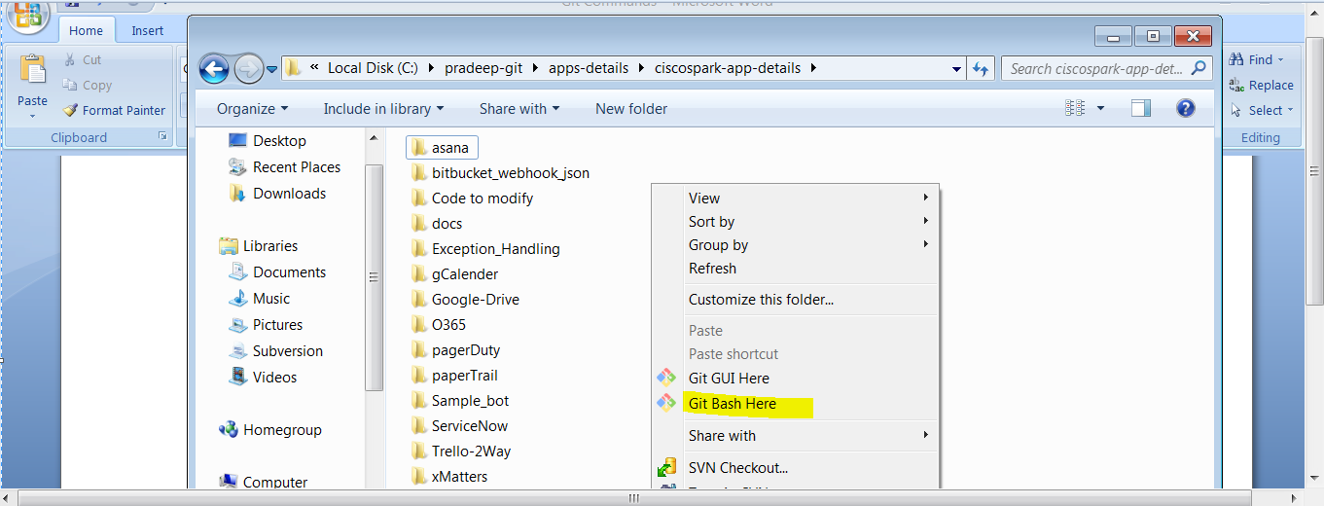

* Now type following command in git bash screen.

git push origin master

it will ask for git account authentication as following. Enter the username and password.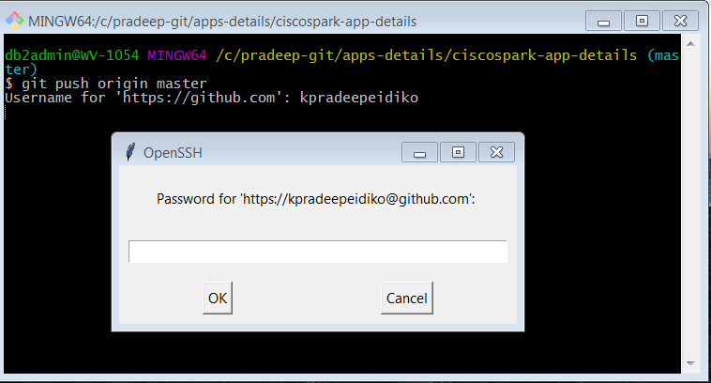

* Finally, your push details will appear as following

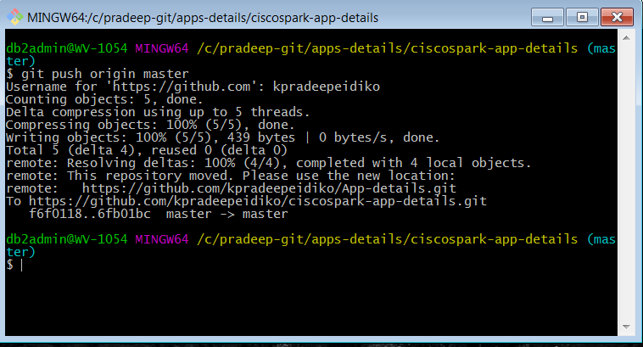

8. Steps to push svn code to git repository:

* create a empty folder and open "Git Bash Here" as following

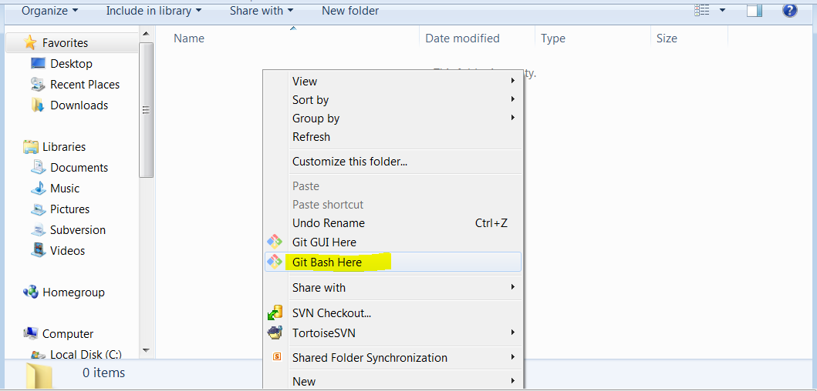

* Now clone svn repository by following command:

git svn clone <svn_repository_url>

Example: Underlined with red ink(in below image)

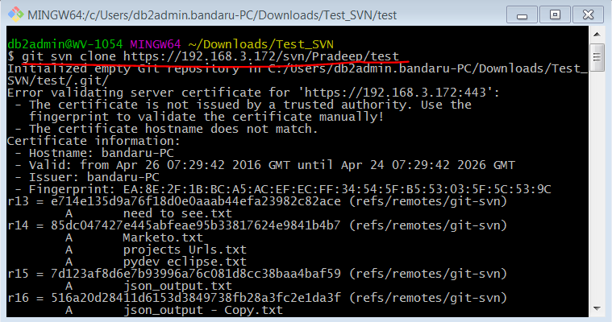

* Now go to svn repository folder by using command "cd <svn_repository_folder>" as follows(Note: Underlined with red ink)

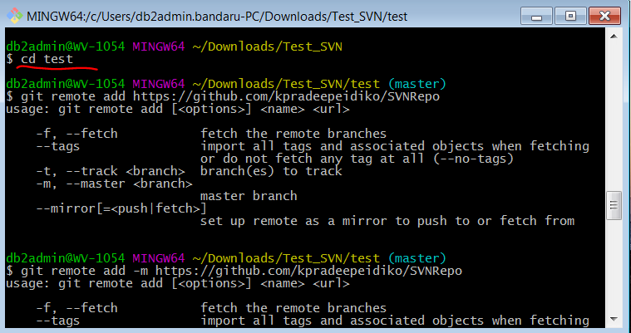

* Now add the git remote repository by following command

git remote add origin <git_repository_url>

Example: underlined with red ink(in below image)

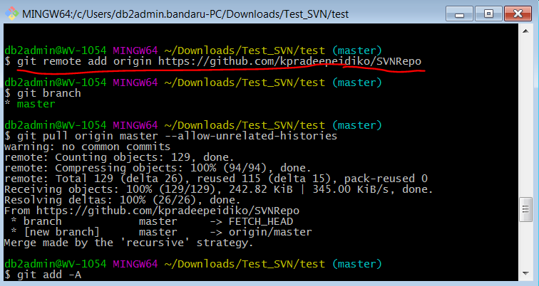

* You should be on master branch, double-check with 'git branch' as following

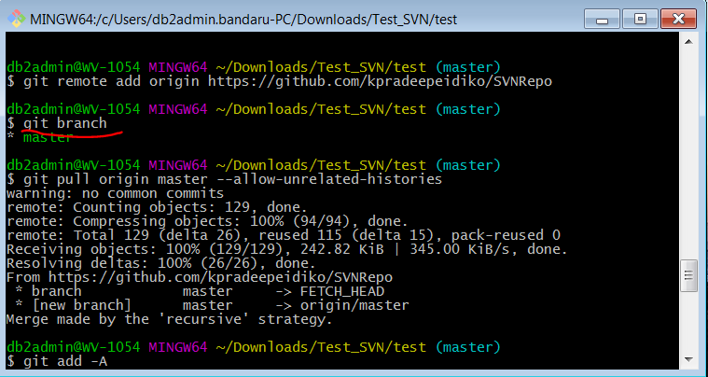

* Now pull the repository by following command

git pull origin branchname --allow-unrelated-histories

Example: Underlined with red ink(in below image)

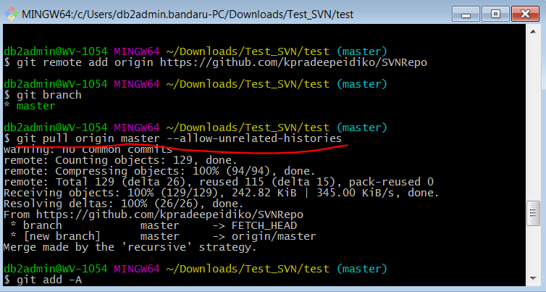

* Now try git "add" command and later "commit" command:

(Note: After commit command if it throws error as: "On branch master nothing to commit, working tree clean", than type the following command "git branch --set-upstream-to origin/master", after "branch" command performed follow git "add" and "commit" commads).

Example: Underlined with red ink(in below images)

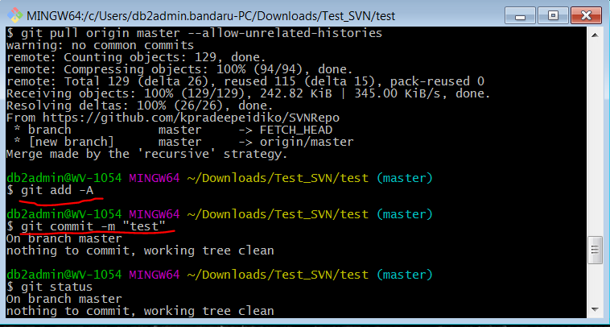

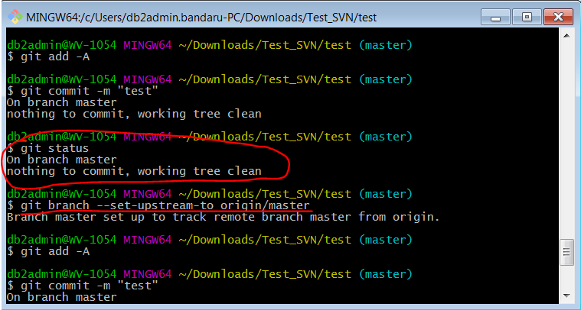

* Now try "push" command as following, On "push" command success check your git repository(from web browser).

Example: Underlined with red ink(in below image)

